BANK LOAN REPORT QUERY DOCUMENT
- BANK LOAN REPORT | SUMMARY

KPI’s:

Total Loan Applications

SELECT COUNT(id) AS Total_Loan_Applications FROM Bank_Loan_Data

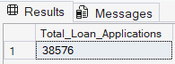

MTD Loan Applications

SELECT COUNT(id) AS MTD_Total_Loan_Applications FROM Bank_Loan_Data
WHERE MONTH(issue_date) = 12 AND YEAR(issue_date) = 2021

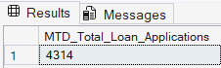

PMTD Loan Applications

SELECT COUNT(id) AS PMTD_Total_Loan_Applications FROM Bank_Loan_Data
WHERE MONTH(issue_date) = 11 AND YEAR(issue_date) = 2021

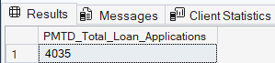

Total Funded Amount

SELECT SUM(loan_amount) AS Total_Funded_Amount FROM Bank_Loan_Data

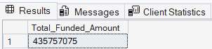

MTD Total Funded Amount

SELECT SUM(loan_amount) AS MTD_Total_Funded_Amount FROM Bank_Loan_Data
WHERE MONTH(issue_date) = 12 AND YEAR(issue_date) = 2021

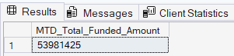

PMTD Total Funded Amount

SELECT SUM(loan_amount) AS PMTD_Total_Funded_Amount FROM Bank_Loan_Data
WHERE MONTH(issue_date) = 11 AND YEAR(issue_date) = 2021

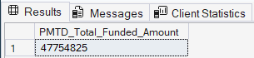

Total Amount Received
SELECT SUM(total_payment) AS Total_Amount_Received FROM Bank_Loan_Data

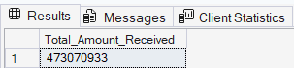

MTD Total Amount Received
SELECT SUM(total_payment) AS MTD_Total_Amount_Received FROM Bank_Loan_Data
WHERE MONTH(issue_date) = 12 AND YEAR(issue_date) = 2021

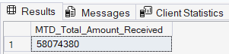

PMTD Total Amount Received
SELECT SUM(total_payment) AS PMTD_Total_Amount_Received FROM Bank_Loan_Data
WHERE MONTH(issue_date) = 11 AND YEAR(issue_date) = 2021

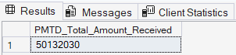

Average Interest Rate
SELECT AVG(int_rate) *100 AS Avg_Interesr_Rate FROM Bank_Loan_Data

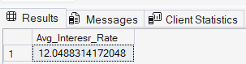

MTD Average Interest

SELECT AVG(int_rate) *100 AS MTD_Avg_Interest_Rate FROM Bank_Loan_Data
WHERE MONTH(issue_date) = 12

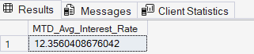

PMTD Average Interest

SELECT AVG(int_rate) *100 AS PMTD_Avg_Interest_Rate FROM Bank_Loan_Data
WHERE MONTH(issue_date) = 11

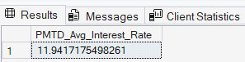

AVG DTI

SELECT AVG(dti)*100 AS Avg_DTI FROM Bank_Loan_Data

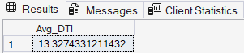

MTD Avg DTI

SELECT AVG(dti)*100 AS MTD_Avg_DTI FROM Bank_Loan_Data
WHERE MONTH(issue_date) = 12

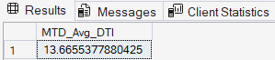

PMTD Avg DTI

SELECT AVG(dti)*100 AS PMTD_Avg_DTI FROM Bank_Loan_Data
WHERE MONTH(issue_date) = 11

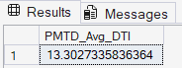

GOOD LOAN ISSUED

Good Loan percentage

SELECT
(COUNT(CASE WHEN loan_status = 'Fully Paid' OR loan_status = 'Current' THEN id END) * 100)
/
COUNT(id) AS Good_loan_percentage
FROM Bank_Loan_Data

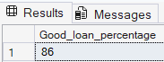

Good Loan Applications

SELECT COUNT(id) AS Good_Loan_Applications FROM Bank_Loan_Data
WHERE loan_status = 'Fully Paid' OR loan_status = 'Current'

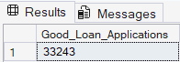

Good Loan Funded Amount

SELECT SUM(total_payment) AS Good_Loan_Received_Amount FROM Bank_Loan_Data
WHERE loan_status = 'Fully Paid' OR loan_status = 'Current'

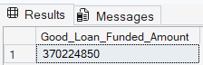

Good Loan Amount Received
SELECT SUM(loan_amount) AS Good_Loan_Funded_Amount FROM Bank_Loan_Data
WHERE loan_status = 'Fully Paid' OR loan_status = 'Current'

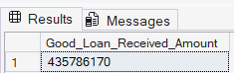

BAD LOAN ISSUED
Bad Loan Percentage
SELECT
(COUNT(CASE WHEN loan_status = 'Charged Off' THEN id END) * 100.0) /
COUNT(id) AS Bad_Loan_Percentage
FROM Bank_Loan_Data

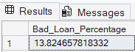

Bad Loan Applications
SELECT COUNT(id) AS Bad_Loan_Applications FROM Bank_Loan_Data
WHERE loan_status = 'Charged Off'

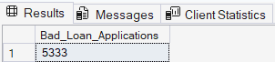

Bad Loan Funded Amount
SELECT SUM(loan_amount) AS Bad_Loan_Funded_Amount FROM Bank_Loan_Data
WHERE loan_status = 'Charged Off'

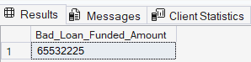

Bad Loan Amount Received
SELECT SUM(total_payment) AS Bad_Loan_Amount_Received FROM Bank_Loan_Data
WHERE loan_status = 'Charged Off'

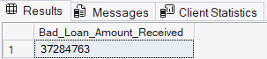

LOAN STATUS
SELECT
loan_status,
COUNT(id) AS LoanCount,
SUM(total_payment) AS Total_Amount_Received,
SUM(loan_amount) AS Total_Funded_Amount,
AVG(int_rate * 100) AS Interest_Rate,
AVG(dti * 100) AS DTI
FROM
Bank_Loan_Data
GROUP BY
loan_status

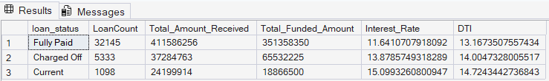

SELECT
loan_status,
SUM(total_payment) AS MTD_Total_Amount_Received,
SUM(loan_amount) AS MTD_Total_Funded_Amount
FROM Bank_Loan_Data
WHERE MONTH(issue_date) = 12
GROUP BY loan_status

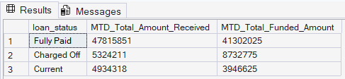

BANK LOAN REPORT | OVERVIEW

MONTH
SELECT
MONTH(issue_date) AS Month_Number,
DATENAME(MONTH, issue_date) AS Month_Name,
COUNT(id) AS Total_Loan_Applications,
SUM(loan_amount) AS Total_Funded_Amount,
SUM(total_payment) AS Total_Amount_Received
FROM Bank_Loan_Data
GROUP BY MONTH(issue_date), DATENAME(MONTH, issue_date)
ORDER BY MONTH(issue_date)

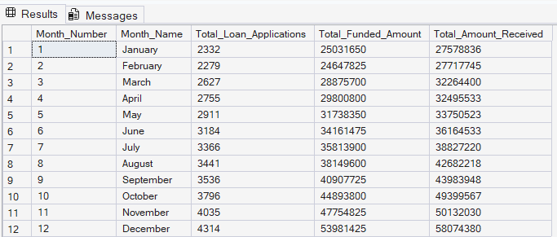

STATE
SELECT
address_state,
COUNT(id) AS Total_Loan_Applications,
SUM(loan_amount) AS Total_Funded_Amount,
SUM(total_payment) AS Total_Amount_Received
FROM Bank_Loan_Data
GROUP BY address_state
ORDER BY address_state
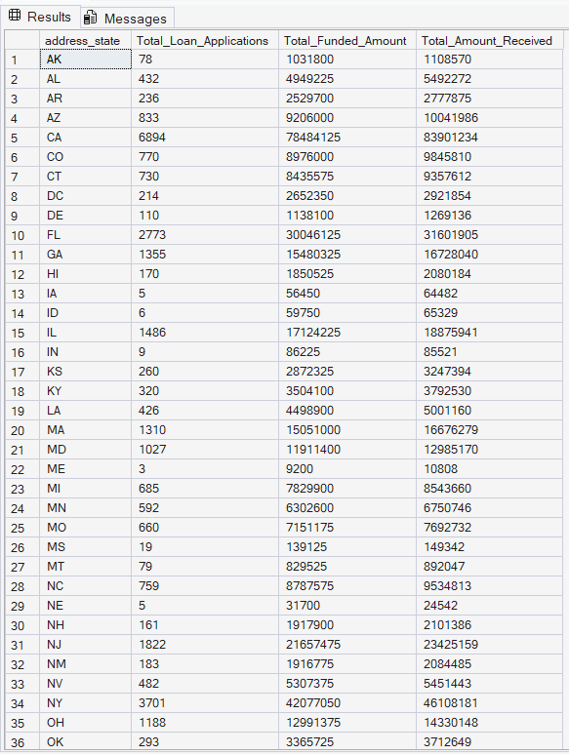

TERM
SELECT
term as Term,
COUNT(id) AS Total_Loan_Applications,
SUM(loan_amount) AS Total_Funded_Amount,
SUM(total_payment) AS Total_Amount_Received
FROM Bank_Loan_Data
GROUP BY term
ORDER BY term

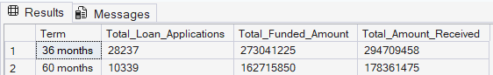

EMPLOYEE LENGTH
SELECT
emp_length,
COUNT(id) AS Total_Loan_Applications,
SUM(loan_amount) AS Total_Funded_Amount,
SUM(total_payment) AS Total_Amount_Received
FROM Bank_Loan_Data
GROUP BY emp_length
ORDER BY emp_length

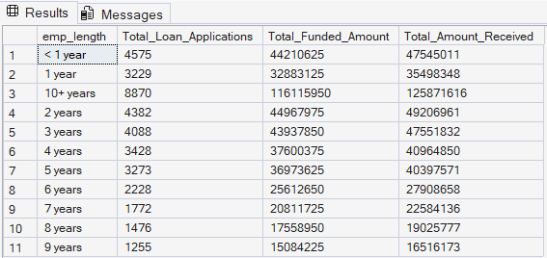

PURPOSE

SELECT
purpose AS Purpose,
COUNT(id) AS Total_Loan_Applications,
SUM(loan_amount) AS Total_Funded_Amount,
SUM(total_payment) AS Total_Amount_Received
FROM Bank_Loan_Data
GROUP BY purpose
ORDER BY purpose

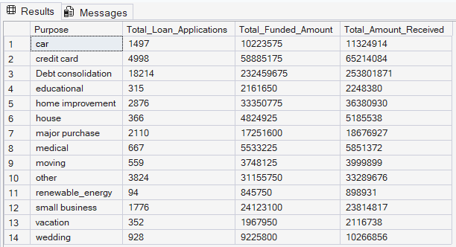

HOME OWNERSHIP

SELECT
home_ownership AS Home_Ownership,
COUNT(id) AS Total_Loan_Applications,
SUM(loan_amount) AS Total_Funded_Amount,
SUM(total_payment) AS Total_Amount_Received
FROM Bank_Loan_Data
GROUP BY home_ownership
ORDER BY home_ownership

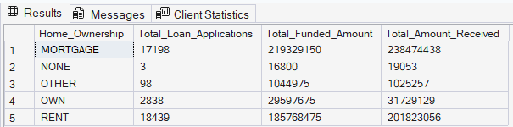

SUMMARY DASHBOARD

Finally, we built an interactive Summary Dashboard to present insights visually.

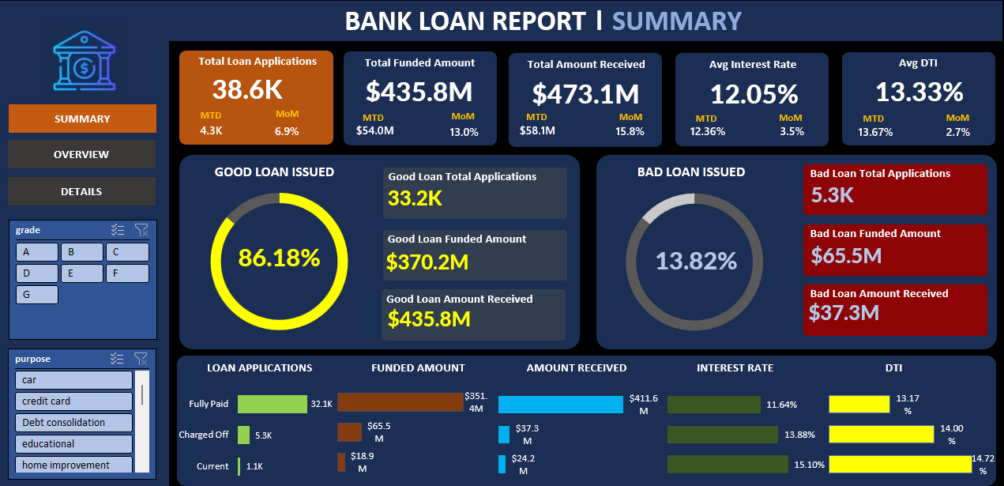

SUMMARY DASHBOARD

Finally, we built an interactive Overview Dashboard to present insights visually.

